St. Brendan’s Episcopal Church
Juneau, Alaska
The Rt. Rev. Mark Lattime, VIIIth Bishop of Alaska
“A Harbor for God’s Love”
Holy Communion with Reserve Sacrament
The Seventeenth Sunday after the Day of Pentecost
September 20, 2026 ~ 10:30 a.m.

The Mission of St. Brendan’s
The mission of St. Brendan’s Episcopal Church is to respond to the
needs of the community and the world in a form that fosters and
encourages a relationship with Jesus Christ.
Welcome visitors. Take time to sign the guest
book in the narthex and join us for coffee hour after the service.
Please join us in worship again, and may God bless your week.

Before the service, speak to the Lord;
during the service, let the Lord speak to you;
after the service, speak to one another.
Holy Communion with Reserve Sacrament
Led by Worship Leaders trained and licensed by the Diocese of Alaska
Dave Muldoon ~ Officiant
Musician ~ Elena

Seventeenth Sunday after the Day of Pentecost
Sunday, September 20, 2026

Liturgy of the Word

Please stand as able and join in singing the opening hymn

Opening Hymn
Lord of all hopefulness, Lord of all joy Hymnal 482
Reprinted & streamed with permission under OneLicenseA-721147

The people standing as able, the Officiant says
 | Blessed be God: Father, Son, and Holy Spirit.
People | And blessed be his kingdom, now and for ever. Amen.
Confession of Sin
All kneel or stand as able.
The Officiant says
Jesus said, “The first commandment is this: Hear, O Israel: The Lord our God is the only Lord. Love the Lord your God with all your heart, with all your soul, with all your mind, and with all your strength. The second is this: Love your neighbor as yourself. There is no other commandment greater than these.” Mark 12:29-31

The Officiant says
Let us confess our sins against God and our neighbor.
Silence
Officiant and People say together
Most merciful God,
we confess that we have sinned against you
in thought, word, and deed,
by what we have done,
and by what we have left undone.
We have not loved you with our whole heart;
we have not loved our neighbors as ourselves.
We are truly sorry and we humbly repent.
For the sake of your Son Jesus Christ,
have mercy on us and forgive us;
that we may delight in your will,
and walk in your ways,
to the glory of your Name. Amen.
The Officiant says
Almighty God have mercy on us, forgive us all our sins through our Lord Jesus Christ, strengthen us in all goodness, and by the power of the Holy Spirit keep us in eternal life. Amen.

The Officiant says
Almighty God, to you all hearts are open, all desires known, and from you no secrets are hid: Cleanse the thoughts of our hearts by the inspiration of your Holy Spirit, that we may perfectly love you, and worthily magnify your holy Name; through Christ our Lord. Amen.

The following is sung, all standing as able.

Gloria Glory & Praise 100
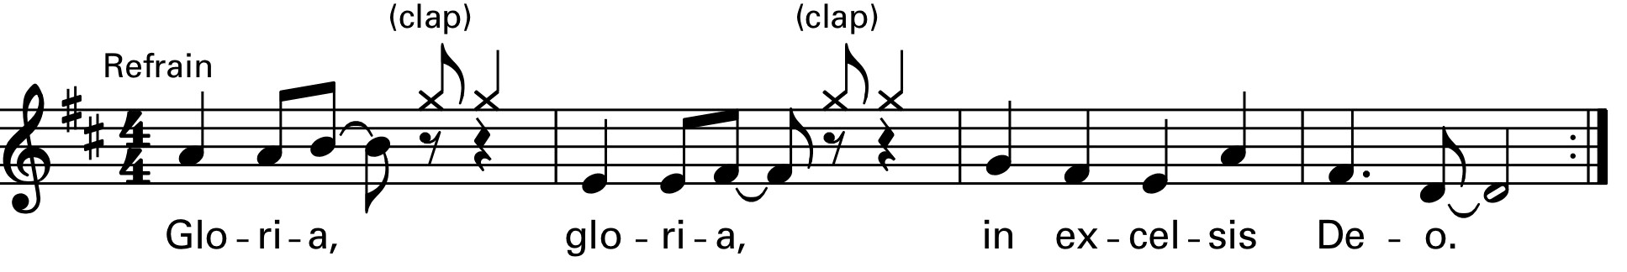

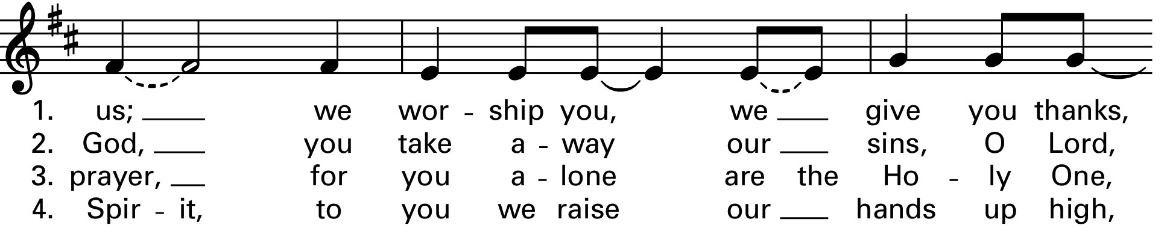
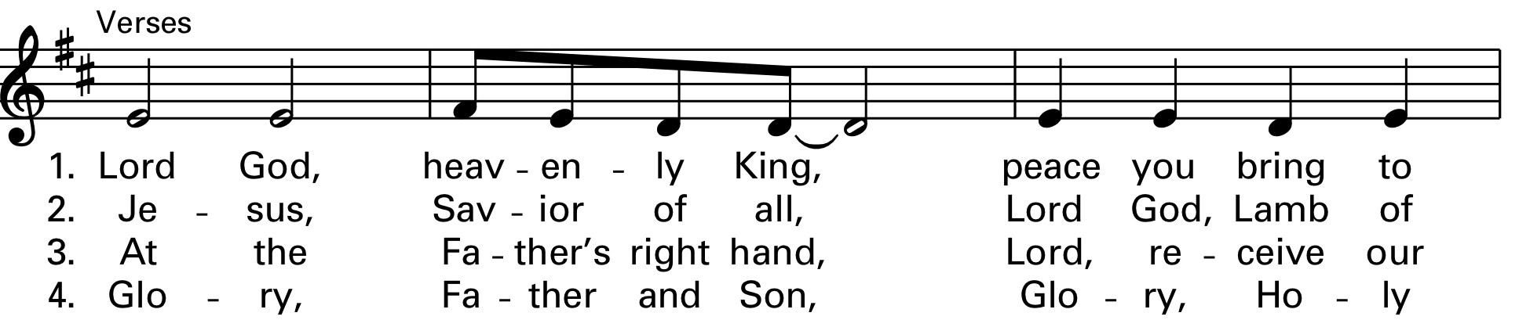
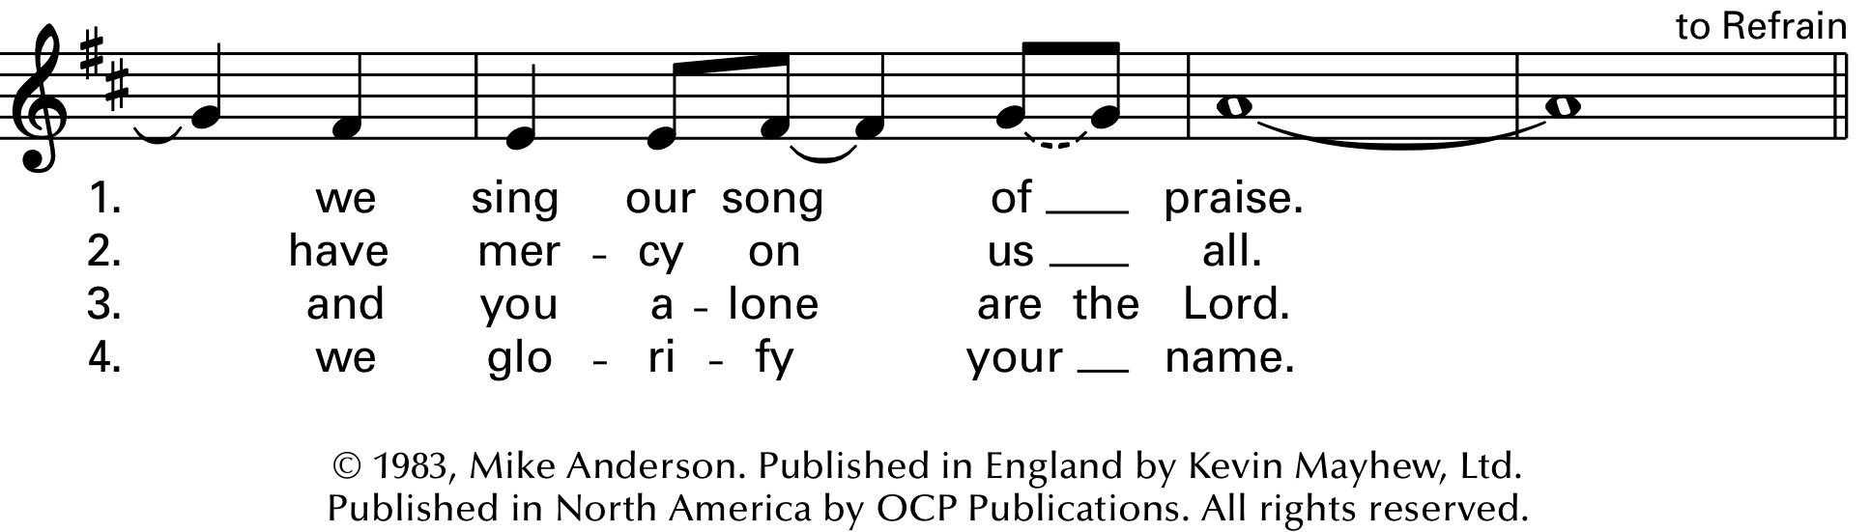
Reprinted & streamed with permission under OneLicenseA-721147

Collect of the Day
Officiant | The Lord be with you
People | And also with you.
Officiant | Let us pray.
Grant us, Lord, not to be anxious about earthly things, but to love things heavenly; and even now, while we are placed among things that are passing away, to hold fast to those that shall endure; through Jesus Christ our Lord, who lives and reigns with you and the Holy Spirit, one God, for ever and ever. Amen.

First Reading Exodus 16:2-15 Rob Smith

All sit.

A Reading from the book of Exodus.
²The whole congregation of the Israelites complained against Moses and Aaron in the wilderness. ³The Israelites said to them, “If only we had died by the hand of the Lord in the land of Egypt, when we sat by the fleshpots and ate our fill of bread; for you have brought us out into this wilderness to kill this whole assembly with hunger.”
⁴Then the Lord said to Moses, “I am going to rain bread from heaven for you, and each day the people shall go out and gather enough for that day. In that way I will test them, whether they will follow my instruction or not. ⁵On the sixth day, when they prepare what they bring in, it will be twice as much as they gather on other days.” ⁶So Moses and Aaron said to all the Israelites, “In the evening you shall know that it was the Lord who brought you out of the land of Egypt, ⁷and in the morning you shall see the glory of the Lord, because he has heard your complaining against the Lord. For what are we, that you complain against us?” ⁸And Moses said, “When the Lord gives you meat to eat in the evening and your fill of bread in the morning, because the Lord has heard the complaining that you utter against him—what are we? Your complaining is not against us but against the Lord.”
⁹Then Moses said to Aaron, “Say to the whole congregation of the Israelites, ‘Draw near to the Lord, for he has heard your complaining.’ ” ¹⁰And as Aaron spoke to the whole congregation of the Israelites, they looked toward the wilderness, and the glory of the Lord appeared in the cloud. ¹¹The Lord spoke to Moses and said, ¹²“I have heard the complaining of the Israelites; say to them, ‘At twilight you shall eat meat, and in the morning you shall have your fill of bread; then you shall know that I am the Lord your God.’ ”
¹³In the evening quails came up and covered the camp; and in the morning there was a layer of dew around the camp. ¹⁴When the layer of dew lifted, there on the surface of the wilderness was a fine flaky substance, as fine as frost on the ground. ¹⁵When the Israelites saw it, they said to one another, “What is it?” For they did not know what it was. Moses said to them, “It is the bread that the Lord has given you to eat.”

Reader | The Word of the Lord.
People | Thanks be to God.

Psalm 105:1-6, 37-45 Sean Murphree
Remain seated.
¹Give thanks to the Lord and call upon his Name; *
make known his deeds among the peoples.
²Sing to him, sing praises to him, *
and speak of all his marvelous works.
³Glory in his holy Name; *
let the hearts of those who seek the Lord rejoice.

⁴Search for the Lord and his strength; *
continually seek his face.
⁵Remember the marvels he has done, *
his wonders and the judgments of his mouth,
⁶O offspring of Abraham his servant, *
O children of Jacob his chosen.
³⁷He led out his people with silver and gold; *
in all their tribes there was not one that stumbled.
³⁸Egypt was glad of their going, *
because they were afraid of them.
³⁹He spread out a cloud for a covering *
and a fire to give light in the night season.
⁴⁰They asked, and quails appeared, *
and he satisfied them with bread from heaven.
⁴¹He opened the rock, and water flowed, *
so the river ran in the dry places.
⁴²For God remembered his holy word *
and Abraham his servant.
⁴³So he led forth his people with gladness, *
his chosen with shouts of joy.
⁴⁴He gave his people the lands of the nations, *
and they took the fruit of others’ toil,
⁴⁵That they might keep his statutes *
and observe his laws.
Hallelujah!

Second Reading Philippians 1:21-30 Jo Schoeppe

A Reading from Paul's letter to the Church in Philippi.

²¹To me, living is Christ and dying is gain. ²²If I am to live in the flesh, that means fruitful labor for me; and I do not know which I prefer. ²³I am hard pressed between the two: my desire is to depart and be with Christ, for that is far better; ²⁴but to remain in the flesh is more necessary for you. ²⁵Since I am convinced of this, I know that I will remain and continue with all of you for your progress and joy in faith, ²⁶so that I may share abundantly in your boasting in Christ Jesus when I come to you again.
²⁷Only, live your life in a manner worthy of the gospel of Christ, so that, whether I come and see you or am absent and hear about you, I will know that you are standing firm in one spirit, striving side by side with one mind for the faith of the gospel, ²⁸and are in no way intimidated by your opponents. For them this is evidence of their destruction, but of your salvation. And this is God’s doing. ²⁹For he has graciously granted you the privilege not only of believing in Christ, but of suffering for him as well—³⁰since you are having the same struggle that you saw I had and now hear that I still have.

Reader | The Word of the Lord.
People | Thanks be to God.
Sequence Hymn
Lamp of our feet Hymnal 627
Holy Gospel Matthew 20:1-16 Dave Muldoon
The congregation may remain seated during the reading
Officiant | A reading from the Holy Gospel of our Lord Jesus Christ according to Matthew.
[Jesus said,] ¹“The kingdom of heaven is like a landowner who went out early in the morning to hire laborers for his vineyard. ²After agreeing with the laborers for the usual daily wage, he sent them into his vineyard. ³When he went out about nine o’clock, he saw others standing idle in the marketplace; ⁴and he said to them, ‘You also go into the vineyard, and I will pay you whatever is right.’ So they went. ⁵When he went out again about noon and about three o’clock, he did the same. ⁶And about five o’clock he went out and found others standing around; and he said to them, ‘Why are you standing here idle all day?’ ⁷They said to him, ‘Because no one has hired us.’ He said to them, ‘You also go into the vineyard.’ ⁸When evening came, the owner of the vineyard said to his manager, ‘Call the laborers and give them their pay, beginning with the last and then going to the first.’ ⁹When those hired about five o’clock came, each of them received the usual daily wage. ¹⁰Now when the first came, they thought they would receive more; but each of them also received the usual daily wage. ¹¹And when they received it, they grumbled against the landowner, ¹²saying, ‘These last worked only one hour, and you have made them equal to us who have borne the burden of the day and the scorching heat.’ ¹³But he replied to one of them, ‘Friend, I am doing you no wrong; did you not agree with me for the usual daily wage? ¹⁴Take what belongs to you and go; I choose to give to this last the same as I
give to you. ¹⁵Am I not allowed to do what I choose with what belongs to me? Or are you envious because I am generous?’ ¹⁶So the last will be first, and the first will be last.”

Officiant | The Word of the Lord.
People | Thanks be to God
Sermon Dave Muldoon
Nicene Creed
All stand as able and together say

We believe in one God,
the Father, the Almighty,
maker of heaven and earth,
of all that is, seen and unseen.
We believe in one Lord, Jesus Christ,
the only Son of God,
eternally begotten of the Father,
God from God, Light from Light,
true God from true God,
begotten, not made,
of one Being with the Father.
Through him all things were made.
For us and for our salvation
he came down from heaven:
by the power of the Holy Spirit
he became incarnate from the Virgin Mary,
and was made man.
For our sake he was crucified under Pontius Pilate;
he suffered death and was buried.
On the third day he rose again
in accordance with the Scriptures;
he ascended into heaven
and is seated at the right hand of the Father.
He will come again in glory to judge the living and the dead,
and his kingdom will have no end.
We believe in the Holy Spirit, the Lord, the giver of life,
who proceeds from the Father and the Son.
With the Father and the Son he is worshiped and glorified.
He has spoken through the Prophets.
We believe in one holy catholic and apostolic Church.
We acknowledge one baptism for the forgiveness of sins.
We look for the resurrection of the dead,
and the life of the world to come. Amen.

Prayers of the People: Form III Ken Vaughn
All remain standing as able.
Father, we pray for your holy catholic Church;
That we all may be one.

Grant that every member of the Church may truly and humbly serve you;
That your Name may be glorified by all people.

We pray for Sean our Presiding Bishop, Mark our Bishop, for all bishops, priests, and deacons;
That they may be faithful ministers of your Word and Sacraments.

We pray for all who govern and hold authority in the nations of the world;
That there may be justice and peace on the earth.

Give us grace to do your will in all that we undertake;
That our works may find favor in your sight.

Have compassion on those who suffer from any grief or trouble;
That they may be delivered from their distress.

We pray for: Patricia & family, Kirkham Family, Lori & family, Katie, Cecelia, Kendon, Mark, Al, Peter, Judy & family, Jim, Marilyn, Caroline, Tamira, Heather, Fred, Sharon & family, David & Jackie, Gavin, Dee, John, Judi, Linda, John, Mike, Ashu, Ann, Eyerus, Maria, Justine, John, Don A., Mariah, Julie, Linda, Penny, Jim, Anne, Aaron & Devonne, Dwayne, Constance, Troy, Cheryl, Jordan, Jeremy; for the victims of domestic violence and gun violence; all who live and work at the Johnson Youth Center, SEARHC’S: Ravens Way, and Lemon Creek Correctional Center; all who live with addictions; all who suffer from long term illnesses; and for those who love and care for them.
Give to the departed eternal rest;
Let light perpetual shine upon them.

We praise you for your saints who have entered into joy;
May we also come to share in your heavenly kingdom.

Let us pray for our own needs and those of others.
Silence
The People may add their own petitions.

The Officiant adds a concluding Collect.
Heavenly Father, you have promised to hear what we ask in the name of your son: Accept and fulfill our petitions, we pray, not as we ask in our ignorance, nor as we deserve in our sinfulness, but as you know and love us in your Son Jesus Christ our Lord. Amen

Peace
All stand as able
Officiant | The peace of the Lord be always with you.
People | And also with you.
The People may greet one another in the name of the Lord.
Holy Communion

The Officiant says
Walk in love, as Christ loved us and gave himself for us, an offering and sacrifice to God. Ephesians 5:2

Today’s loose offering will go to the General Fund
Offertory Hymn: O Master, let me walk with thee Hymnal 660

The People stand as able and sing the Doxology as the offering is brought forward and placed on the Credence Table.

Doxology (a hymn of praise)
Praise God from whom all blessings flow: Praise Him all creatures here below.
Praise Him above ye heavenly host;
Praise Father, Son, and Holy Ghost.
The service continues with the authorized Thanksgiving Prayer, all stand as able.

Prayer of Preparation for Communion
The Great Thanksgiving

The Officiant and the people say
Almighty God, Father of all mercies,
we your unworthy servants give you humble thanks for all your goodness and loving-kindness to us and to all whom you have made. We bless you for our creation, preservation, and all the blessings of this life; but above all for your immeasurable love
in the redemption of the world by our Lord Jesus Christ; for the means of grace, and for the hope of glory.
And, we pray, give us such an awareness of your mercies, that with truly thankful hearts we may show forth your praise, not only with our lips, but in our lives, by giving up our selves to your service, and by walking before you
in holiness and righteousness all our days; through Jesus Christ our Lord, to whom, with you and the Holy Spirit, be honor and glory throughout all ages. Amen.

And now, as our Savior
Christ has taught us,
we are bold to sing,
People and Officiant
Our Father, who art in heaven,
hallowed be thy Name,
thy kingdom come,
thy will be done, on earth as it is in heaven.
Give us this day our daily bread.
And forgive us our trespasses,
as we forgive those who trespass against us.
And lead us not into temptation,
but deliver us from evil.
For thine is the kingdom,
and the power, and the glory,
forever and ever. Amen.

The Officiant says
The Gifts of God for the People of God. Take them in remembrance that Christ died for you, and feed on him in your hearts by faith, with thanksgiving.
All are welcome at the Lord's table. We are no longer strangers or guests but one family in the Lord. Let the Worship Leader know if you would prefer alcohol free wine. Chalice Bearers - Jo Schoeppe & Rob Smith

Communion Music Elena Levi

After Communion, the Officiant says
Let us pray.
Officiant and People
Eternal God, heavenly Father,
you have graciously accepted us as living members
of your Son our Savior Jesus Christ,
and you have fed us with spiritual food
in the Sacrament of his Body and Blood.
Send us now into the world in peace,
and grant us strength and courage
to love and serve you
with gladness and singleness of heart;
through Christ our Lord. Amen.
Please remain standing as able for any birthdays or anniversaries and together say
Prayer for Birthdays (BCP 830, prayer 50)
O God, our times are in your hand: Look with favor, we pray, on your servant N. as he begins another year. Grant that he may grow in wisdom and grace, and strengthen his trust in your goodness all the days of his life; through Jesus Christ our Lord. Amen.

Prayer for Anniversaries (BCP p. 431)
O God, you have so consecrated the covenant of marriage that in it is represented the spiritual unity between Christ and his Church: Send therefore your blessing upon these your servants, N. that they may so love, honor, and cherish each other in faithfulness and patience, in wisdom and true godliness. That their home may be a haven of blessing and peace; through Jesus Christ our Lord, who lives and reigns with you and the Holy Spirit, one God, now and for ever. Amen.

Announcements
People may be seated and announcements are now made.

Closing Hymn: Singing songs of expectation Hymnal 527

Dismissal
Officiant | Let us go forth into the world, rejoicing in the power of the Spirit.
People | Thanks be to God.
The Officiant says
The grace of our Lord Jesus Christ, and the love of God, and the fellowship of the Holy Spirit, be with us all evermore. Amen

From riteplanning.com.
Copyright © 2026 Church Publishing Inc. All rights reserved.



Serving Schedule ~ September 6 – September 30, 2026

 | Sept. 6 | Sept. 13 | Sept. 20 | Sept. 27 | October 4
Altar | Dave Muldoon | Lori Seymour | Brita Rice | Tonya  Muldoon | Dave Muldoon
1st  Reading | Sean  Murphree | Ken Vaughan | Brita Rice | Rob Smith | Elena Levi
Psalm | Brita rice | Lucy Merrell | Sean  Murphree | Dave Muldoon | Sean  Murphree
2nd  Reading | Jo Schoeppe | Barbara  Learmonth | Jo Schoeppe | Lucy Merrell | Brita Rice
Gospel | Barbara  Learmonth | Michael  Rowcroft | Dave Muldoon | Jo Schoeppe | Dave Muldoon
Prayers of the People | Rob Smith | Elena Levi | Ken Vaughan | Dave Muldoon | Jo Schoeppe
Chalice  Bearer | Jo Schoeppe & Rob Smith | Barbara  Learmonth &  Dave Muldoon | Jo Schoeppe & Rob Smith | Dave Muldoon & Rob Smith | Jo Schoeppe & Rob Smith
Worship  Leader | Barbara  Learmonth | Michael  Rowcroft | Dave Muldoon | Jo Schoeppe | Dave Muldoon
Godly Play | Summer Break | Godly Play | Godly Play | Godly Play | Godly Play
Coffee  Hour | Ingrid | Ingrid | Carla | ? | ?
Ushers | Jeff & Carol Fujioka | Dave Muldoon | Alec Muldoon | Ingrid Zaruba | Jeff & Carol Fujioka



