St. Brendan’s Episcopal Church
Juneau, Alaska
The Rt. Rev. Mark Lattime, VIIIth Bishop of Alaska
“A Harbor for God’s Love”
Holy Communion with Reserve Sacrament
The Eighteenth Sunday after the Day of Pentecost
September 27, 2026 ~ 10:30 a.m.

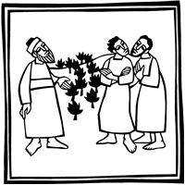

The Mission of St. Brendan’s
The mission of St. Brendan’s Episcopal Church is to respond to the
needs of the community and the world in a form that fosters and
encourages a relationship with Jesus Christ.
Welcome visitors. Take time to sign the guest
book in the narthex and join us for coffee hour after the service.
Please join us in worship again, and may God bless your week.
Before the service, speak to the Lord;
during the service, let the Lord speak to you;
after the service, speak to one another.
Holy Communion with Reserve Sacrament
Led by Worship Leaders trained and licensed by the Diocese of Alaska
Officiant ~Jo Schoeppe
Musician ~ Elena

Eighteenth Sunday after the Day of Pentecost
Sunday September 27, 2026

Liturgy of the Word

Please stand as able and join in singing the opening hymn
Opening Hymn All hail the power of Jesus' Name Hymn 450

Reprinted & streamed with permission under OneLicenseA-721147

The people standing as able, the Officiant says
 | Blessed be God: Father, Son, and Holy Spirit.
People | And blessed be God's kingdom, now and for ever. Amen.

Confession of Sin
All kneel or stand as able
The Officiant says
If we say that we have no sin, we deceive ourselves, and the truth is not in us. But if we confess our sins, God, who is faithful and just, will forgive our sins and cleanse us from all unrighteousness. 1 John 1:8, 9

The Officiant says
Let us confess our sins against God and our neighbor.
Silence.

Officiant and People
Most merciful God,
we confess that we have sinned against you
in thought, word, and deed,
by what we have done,
and by what we have left undone.
We have not loved you with our whole heart;
we have not loved our neighbors as ourselves.
We are truly sorry and we humbly repent.
For the sake of your Son Jesus Christ,
have mercy on us and forgive us;
that we may delight in your will,
and walk in your ways,
to the glory of your Name. Amen.

Officiant says
Almighty God have mercy on us, forgive us all our sins through our Lord Jesus Christ, strengthen us in all goodness, and by the power of the Holy Spirit keep us in eternal life. Amen.

The Officiant says
Almighty God, to you all hearts are open, all desires known, and from you no secrets are hid: Cleanse the thoughts of our hearts by the inspiration of your Holy Spirit, that we may perfectly love you, and worthily magnify your holy Name; through Christ our Lord. Amen.

Gloria Glory & Praise 100
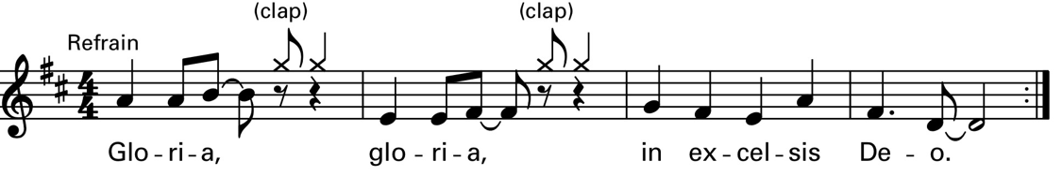

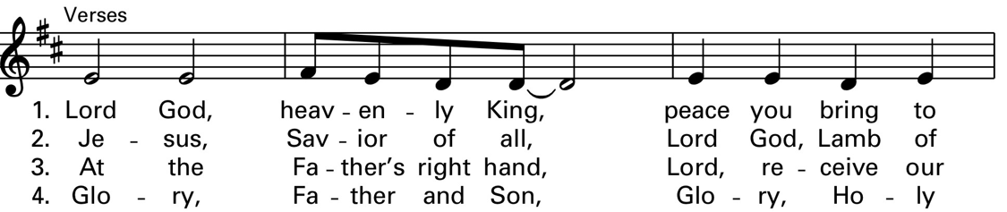

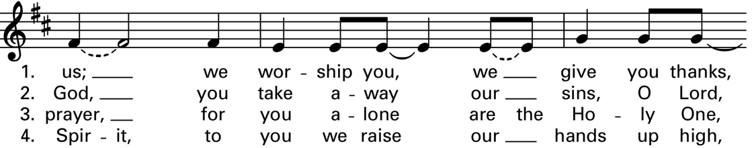

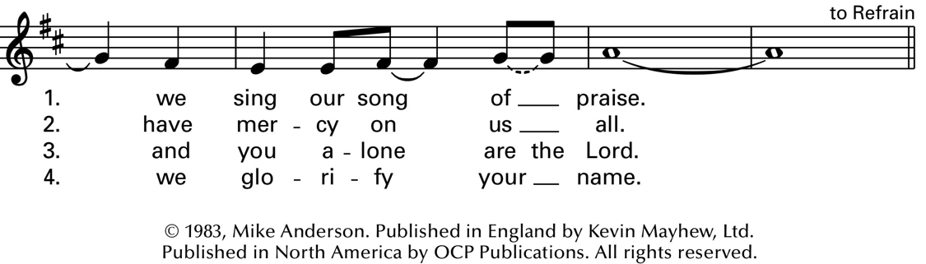
Reprinted & streamed with permission under OneLicenseA-721147

Collect of the Day

Officiant | The Lord be with you.
People | And also with you.
Officiant | Let us pray.
O God, you declare your almighty power chiefly in showing mercy and pity: Grant us the fullness of your grace, that we, running to obtain your promises, may become partakers of your heavenly treasure; through Jesus Christ our Lord, who lives and reigns with you and the Holy Spirit, one God, for ever and ever. Amen.

First Reading Exodus 17:1-7 Rob Smith
The people sit.
A Reading from the book of Exodus.

¹From the wilderness of Sin the whole congregation of the Israelites journeyed by stages, as the Lord commanded. They camped at Rephidim, but there was no water for the people to drink. ²The people quarreled with Moses, and said, “Give us water to drink.” Moses said to them, “Why do you quarrel with me? Why do you test the Lord?” ³But the people thirsted there for water; and the people complained against Moses and said, “Why did you bring us out of Egypt, to kill us and our children and livestock with thirst?” ⁴So Moses cried out to the Lord, “What shall I do with this people? They are almost ready to stone me.” ⁵The Lord said to Moses, “Go on ahead of the people, and take some of the elders of Israel with you; take in your hand the staff with which you struck the Nile, and go. ⁶I will be standing there in front of you on the rock at Horeb. Strike the rock, and water will come out of it, so that the people may drink.” Moses did so, in the sight of the elders of Israel. ⁷He called the place Massah and Meribah, because the Israelites quarreled and tested the Lord, saying, “Is the Lord among us or not?”

Reader | The Word of the Lord.
People | Thanks be to God.

Psalm 78:1-4, 12-16 Dave Muldoon
Remain seated.
¹Hear my teaching, O my people; *
incline your ears to the words of my mouth.
²I will open my mouth in a parable; *
I will declare the mysteries of ancient times.
³That which we have heard and known,
and what our forefathers have told us, *
we will not hide from their children.
⁴We will recount to generations to come
the praiseworthy deeds and the power of the Lord, *
and the wonderful works he has done.
¹²He worked marvels in the sight of their forefathers, *
in the land of Egypt, in the field of Zoan.
¹³He split open the sea and let them pass through; *
he made the waters stand up like walls.
¹⁴He led them with a cloud by day, *
and all the night through with a glow of fire.
¹⁵He split the hard rocks in the wilderness *
and gave them drink as from the great deep.
¹⁶He brought streams out of the cliff, *
and the waters gushed out like rivers.

Second Reading Philippians 2:1-13 Lucy Merrell
The people sit.

A Reading from Paul's letter to the Church in Philippi.
¹If then there is any encouragement in Christ, any consolation from love, any sharing in the Spirit, any compassion and sympathy, ²make my joy complete: be of the same mind, having the same love, being in full accord and of one mind. ³Do nothing from selfish ambition or conceit, but in humility regard others as better than yourselves. ⁴Let each of you look not to your own interests, but to the interests of others. ⁵Let the same mind be in you that was in Christ Jesus, ⁶who, though he was in the form of God, did not regard equality with God as something to be exploited, ⁷but emptied himself, taking the form of a slave, being born in human likeness. And being found in human form, ⁸he humbled himself and became obedient to the point of death— even death on a cross. ⁹Therefore God also highly exalted him and gave him the name that is above every name,¹⁰so that at the name of Jesus every knee should bend, in heaven and on earth and under the earth, ¹¹and every tongue should confess that Jesus Christ is Lord, to the glory of God the Father. ¹²Therefore, my beloved, just as you have always obeyed me, not only in my presence, but much more now in my absence, work out your own salvation with fear and trembling; ¹³for it is God who is at work in you, enabling you both to will and to work for his good pleasure.

Reader | The Word of the Lord.
People | Thanks be to God.
Sequence Hymn Rock of ages, cleft for me Hymn 685

Holy Gospel Matthew 21:23-32 Jo Schoeppe
The congregation may remain seated during the reading of the Gospel
Officiant | A reading from the Holy Gospel of our Lord Jesus Christ according to Matthew.
²³When [Jesus] entered the temple, the chief priests and the elders of the people came to him as he was teaching, and said, “By what authority are you doing these things, and who gave you this authority?” ²⁴Jesus said to them, “I will also ask you one question; if you tell me the answer, then I will also tell you by what authority I do these things. ²⁵Did the baptism of John come from heaven, or was it of human origin?” And they argued with one another, “If we say, ‘From heaven,’ he will say to us, ‘Why then did you not believe him?’ ²⁶But if we say, ‘Of human origin,’ we are afraid of the crowd; for all regard John as a prophet.” ²⁷So they answered Jesus, “We do not know.” And he said to them, “Neither will I tell you by what authority I am doing these things.
²⁸“What do you think? A man had two sons; he went to the first and said, ‘Son, go and work in the vineyard today.’ ²⁹He answered, ‘I will not’; but later he changed his mind and went. ³⁰The father went to the second and said the same; and he answered, ‘I go, sir’; but he did not go. ³¹Which of the two did the will of his father?” They said, “The first.” Jesus said to them, “Truly I tell you, the tax collectors and the prostitutes are going into the kingdom of God ahead of you. ³²For John came to you in the way of righteousness and you did not believe him, but the tax collectors and the prostitutes believed him; and even after you saw it, you did not change your minds and believe him.”

Officiant | The Word of the Lord.
People | Thanks be to God

Sermon Jo Schoeppe

Nicene Creed

All stand as able and together say
We believe in one God,
the Father, the Almighty,
maker of heaven and earth,
of all that is, seen and unseen.
We believe in one Lord, Jesus Christ,
the only Son of God,
eternally begotten of the Father,
God from God, Light from Light,
true God from true God,
begotten, not made,
of one Being with the Father.
Through him all things were made.
For us and for our salvation
he came down from heaven:
by the power of the Holy Spirit
he became incarnate from the Virgin Mary,
and was made man.
For our sake he was crucified under Pontius Pilate;
he suffered death and was buried.
On the third day he rose again
in accordance with the Scriptures;
he ascended into heaven
and is seated at the right hand of the Father.
He will come again in glory to judge the living and the dead,
and his kingdom will have no end.
We believe in the Holy Spirit, the Lord, the giver of life,
who proceeds from the Father and the Son.
With the Father and the Son he is worshiped and glorified.
He has spoken through the Prophets.
We believe in one holy catholic and apostolic Church.
We acknowledge one baptism for the forgiveness of sins.
We look for the resurrection of the dead,
and the life of the world to come. Amen.

Prayers of the People: Form VI Dave Muldoon
All remain standing as able

In peace, we pray to you, Lord God.
Silence

For all people in their daily life and work;
For our families, friends, and neighbors, and for those who are alone.

For this community, the nation, and the world;
For all who work for justice, freedom, and peace.

For the just and proper use of your creation;
For the victims of hunger, fear, injustice, and oppression.

For all who are in danger, sorrow, or any kind of trouble;
For those who minister to the sick, the friendless, and the needy.

We pray for: Jeff, Patricia & family, Kirkham Family, Lori & family, Katie, Cecelia, Kendon, Mark, Al, Peter, Judy & family, Jim, Marilyn, Caroline, Tamira, Heather, Fred, Sharon & family, David & Jackie, Gavin, Dee, John, Judi, Linda, John, Mike, Ashu, Ann, Eyerus, Maria, Justine, John, Don A., Mariah, Julie, Linda, Penny, Jim, Anne, Aaron & Devonne, Dwayne, Constance, Troy, Cheryl, Jordan, Jeremy; for the victims of domestic violence and gun violence; all who live and work at the Johnson Youth Center, SEARHC’S: Ravens Way, and Lemon Creek Correctional Center; all who live with addictions; all who suffer from long term illnesses; and for those who love and care for them.
For the peace and unity of the Church of God;
For all who proclaim the Gospel, and all who seek the Truth.

For Sean. our Presiding Bishop, and Mark our Bishop(s); and for all bishops and other ministers;
For all who serve God in his Church.

For the special needs and concerns of this congregation.
Silence
The People may add their own petitions
Hear us, Lord;
For your mercy is great.

We thank you, Lord, for all the blessings of this life.
Silence
The People may add their own thanksgivings

We will exalt you, O God our King;
And praise your Name for ever and ever.

We pray for all who have died, that they may have a place in your eternal kingdom.
Silence
The People may add their own petitions

Lord, let your loving-kindness be upon them;
Who put their trust in you.

The Officiant adds a concluding Collect.

Heavenly Father, you have promised to hear what we ask in the name of your son: Accept and fulfill our petitions, we pray, not as we ask in our ignorance, nor as we deserve in our sinfulness, but as you know and love us in your Son Jesus Christ our Lord. Amen

Peace
All stand as able
Officiant | The peace of the Lord be always with you.
People | And also with you.
The People may greet one another in the name of the Lord.

Holy Communion

The Officiant says
Offer to God a sacrifice of thanksgiving, and make good your vows to the Most High. Psalm 50:14

Today’s loose offering will go to the Vestry Discretionary Fund
Offertory Hymn
Sing, ye faithful, sing with gladness Hymn 492
The People stand as able and sing the Doxology as the offering is brought forward and placed on the Credence Table.

Doxology (a hymn of praise)
Praise God from whom all blessings flow: Praise Him all creatures here below.
Praise Him above ye heavenly host;
Praise Father, Son, and Holy Ghost.

Prayer of Preparation for Communion
The General Thanksgiving

The Officiant and the people say
Almighty God, Father of all mercies,
we your unworthy servants give you humble thanks for all your goodness and loving-kindness to us and to all whom you have made. We bless you for our creation, preservation, and all the blessings of this life; but above all for your immeasurable love
in the redemption of the world by our Lord Jesus Christ; for the means of grace, and for the hope of glory.
And, we pray, give us such an awareness of your mercies, that with truly thankful hearts we may show forth your praise, not only with our lips, but in our lives, by giving up our selves to your service, and by walking before you
in holiness and righteousness all our days; through Jesus Christ our Lord, to whom, with you and the Holy Spirit, be honor and glory throughout all ages. Amen.

And now, as our Savior
Christ has taught us,
we are bold to sing,
People and Officiant
Our Father, who art in heaven,
hallowed be thy Name,
thy kingdom come,
thy will be done, on earth as it is in heaven.
Give us this day our daily bread.
And forgive us our trespasses,
as we forgive those who trespass against us.
And lead us not into temptation,
but deliver us from evil.
For thine is the kingdom,
and the power, and the glory,
forever and ever. Amen.

The Officiant says
The Gifts of God for the People of God. Take them in remembrance that Christ died for you, and feed on him in your hearts by faith, with thanksgiving.
All are welcome at the Lord's table. We are no longer strangers or guests but one family in the Lord. Let the Worship Leader know if you would prefer alcohol free wine. Chalice Bearers – Dave Muldoon & Rob Smith

Communion Music Elena Levi
After Communion, the Officiant says
Let us pray.
Celebrant and People
Eternal God, heavenly Father,
you have graciously accepted us as living members
of your Son our Savior Jesus Christ,
and you have fed us with spiritual food
in the Sacrament of his Body and Blood.
Send us now into the world in peace,
and grant us strength and courage
to love and serve you
with gladness and singleness of heart;
through Christ our Lord. Amen.

Please remain standing as able for any birthdays or anniversaries and together say
Prayer for Birthdays (BCP 830, prayer 50)
O God, our times are in your hand: Look with favor, we pray, on your servant N. as he begins another year. Grant that he may grow in wisdom and grace, and strengthen his trust in your goodness all the days of his life; through Jesus Christ our Lord. Amen.

Prayer for Anniversaries (BCP p. 431)
O God, you have so consecrated the covenant of marriage that in it is represented the spiritual unity between Christ and his Church: Send therefore your blessing upon these your servants, N. that they may so love, honor, and cherish each other in faithfulness and patience, in wisdom and true godliness. That their home may be a haven of blessing and peace; through Jesus Christ our Lord, who lives and reigns with you and the Holy Spirit, one God, now and for ever. Amen.

Announcements
People may be seated and announcements are now made.
Stewardship Drive Starts next Sunday October 4th

Closing Hymn Lord, dismiss us with thy blessing Hymn 344

Hymn 344 continues on next page

Dismissal
Officiant | Let us go forth into the world, rejoicing in the power of the Spirit.
People | Thanks be to God.

The Officiant says
The blessing, mercy, and grace of God Almighty, the Father, the Son, and the Holy Spirit, be upon us, and remain with us for ever. Amen.

From riteplanning.com.
Copyright © 2026 Church Publishing Inc. All rights reserved.

Serving Schedule ~ September 6 – September 30, 2026

 | Sept. 6 | Sept. 13 | Sept. 20 | Sept. 27 | October 4
Altar | Dave Muldoon | Lori Seymour | Brita Rice | Tonya  Muldoon | Dave Muldoon
1st  Reading | Sean  Murphree | Ken Vaughan | Brita Rice | Rob Smith | Elena Levi
Psalm | Brita rice | Lucy Merrell | Sean  Murphree | Dave Muldoon | Sean  Murphree
2nd  Reading | Jo Schoeppe | Barbara  Learmonth | Jo Schoeppe | Lucy Merrell | Brita Rice
Gospel | Barbara  Learmonth | Michael  Rowcroft | Dave Muldoon | Jo Schoeppe | Dave Muldoon
Prayers of the People | Rob Smith | Elena Levi | Ken Vaughan | Dave Muldoon | Jo Schoeppe
Chalice  Bearer | Jo Schoeppe & Rob Smith | Barbara  Learmonth &  Dave Muldoon | Jo Schoeppe & Rob Smith | Dave Muldoon & Rob Smith | Jo Schoeppe & Rob Smith
Worship  Leader | Barbara  Learmonth | Michael  Rowcroft | Dave Muldoon | Jo Schoeppe | Dave Muldoon
Godly Play | Summer Break | Godly Play | Godly Play | Godly Play | Godly Play
Coffee  Hour | Ingrid | Ingrid | Carla | ? | ?
Ushers | Jeff & Carol Fujioka | Dave Muldoon | Alec Muldoon | Ingrid Zaruba | Jeff & Carol Fujioka



